**Volunteer Reimbursement Policy**

**DOCUMENT CONTROL**

*This is a controlled document. Whilst this document may be printed, the electronic version posted on the intranet is the controlled copy. Any printed copies of this document are not controlled. As a controlled document, this document should not be saved onto local or network drives but should always be accessed from the website.*

* Do you really need to print this document?*

*Please consider the environment before you print this document and where copies should be printed double-sided. Please also consider setting the Page Range in the Print properties, when relevant to do so, to avoid printing the policy in its entirety.*

|  |  |
| --- | --- |
| **Document Owner:** | HWE ICB Chief of Staff |
| **Document Author(s):** | HWE ICB Public Engagement Manager |
| **Version:** | V2.4 |
| **Approved By:** | HWE ICB Executive Committee |
| **Date of Approval:** | **17 February 2025** |
| **Date of Review:** | **February 2027** |
| **Link to Strategic Objective(s):** | Patient involvement on all strategic objectives |

Change and Approval History:

|  |  |  |  |
| --- | --- | --- | --- |
| **Version** | **Revision Description** | **Reviewer / Approval Group** | **Date of Review / Approval** |
| 0.1 | Policy developed and approved |  |  |
| 0.2 | Formatting and EQIA sign off obtained> |  |  |
| **1.0** | **Final - Approved** | ICB Board | 21.6.22 |
| **2.1** | **Review of document:**   * Formatted into corporate template * Appendix added –Expense form * EqIA updated. | Heather Aylward,  Engagement Manager |  |
| 2.2 | Updated August 2024   * Add to health inequalities section on what is being proposed supports people who face inequalities | Reviewed by Paul Curry re EQIA | 4.9. 2024 |
|  | Amendments added   * Add ‘two year review of existing document’ * Amend job titles * Rephrase information | Louise Manders | 26.9.2024 |
| 2.3 | Updated September 2024   * Added to 1.3.1. table “In line with our general approach as an organisation to reduce incidental costs of this nature”. | Final reviewed and approved by Michael Watson | 15.10.2024 |
| 2.4 | Updated February 2025   * Under section 2.3 added that volunteers are responsible for getting authorisation for expenses that need to be agreed in advance | ICB Exec review | 03.02.2025 |
| 2.4 | Final - Approved | HWE ICB Executive Committee | 17.02.2025 |

**CONTENT**

|  |  |  |  |  |  |
| --- | --- | --- | --- | --- | --- |
| **Section No.** | |  | | **Page No.** | |
| **1.0** | | Introduction – Purpose, Scope, and Definitions   1. Introduction   1.1 Purpose  1.2 Scope  1.3 Definitions  1.3.1 Volunteer  1.3.2 Reimbursement | | **4** | |
| **2.0** | | Roles and Responsibilities – Implementation and Monitoring  2.1 ICB Communications and Engagement Team  2.2 ICB Executive Team  2.3 Volunteers  2.4 ICB staff | | **5** | |
| **3.0** | | 3.1 Implementation  3.2 Reimbursement Expenses  3.3 Rates of payment | | **7** | |
| **4.0** | | Process | | **7** | |
| **5.0** | | Monitoring | |  | |
|  | | Appendix 1 – Equality and Health Inequalities Analysis | |  | |

**1.0** **Introduction**

1.1 The ICB encourages and facilitates the maximum possible volunteer participation in our work. There is strong evidence that health and care services are better when people who use them are involved in their design. For effective participation, people need to feel supported and to know their voluntary contribution is valued and has impact.

The ICB is committed to playing its part in removing financial barriers to involvement and to ensure that volunteers are reimbursed for out-of-pocket expenses.

* 1. **Purpose**

1.1.1This policy outlines the reimbursement process and it applies to individual volunteers involved in the work of the ICB, for example as volunteer patient members of the Patient Engagement Forum, procurement processes, working groups and as guidance for staff who work with volunteers

It does not apply to patient and public organisations such as those from the voluntary, community, faith and social enterprise (VCFSE) sector. Our arrangements and engagement policies with this sector are agreed within the ICB’s VCFSE Alliance.

**1.2 Scope**

1.2.1 This policy applies to:

1. All ICB volunteers
2. ICB staff working with volunteers

**1.3 Definitions**

1.3.1 This policy is in line with our general approach as an organisation to reduce incidental costs of this nature. The following definitions apply in the context of this policy:

|  |  |
| --- | --- |
| **Term** | **Definition** |
| Volunteer | A volunteer is anyone aged 16 or over who supports the work of the Herts and West Essex Integrated Care Board (ICB) by giving their time, skills and experience in an unpaid capacity beyond the reimbursement of expenses. The ICB’s Patient Safety Partners are covered by a separate policy as their involvement requires training and is set nationally. |
| Reimbursement | * travel and parking, including alternative transport arrangements such as taxis when necessary and agreed in advance. Parking costs will be met for the duration of the meeting. Parking fines are not covered * receipted costs for caring arrangements, including childcare. This may be paid at an appropriate rate dependent on individual circumstances and should be discussed and agreed in advance * interpretation support, signer, personal assistant or advocate costs necessary for participation. This should be discussed and agreed in advance so appropriate arrangements can be made. When volunteers need a carer / support worker to accompany them to an activity the ICB will reimburse reasonable expenses / costs of this support if not provided elsewhere (such as via support payments). * subsistence: if the attendance (including travel) exceeds 5 hours and refreshments are not provided, receipted expenses may be claimed. These will cover meals and non- alcoholic drinks. A guide price would be a maximum of £10 for lunch /breakfast and £15 for an evening meal * where a volunteer is asked by the ICB to attend a conference or event. In these cases, the cost will be reimbursed including reasonable out-of-pocket expenses and very rarely, accommodation costs. Payment in advance of travel will be made if essential, taking into account the cost of living for individuals facing financial difficulties. Receipts must be provided after the event and any unused reimbursement repaid. All arrangements will be agreed in advance * incidental costs such as printing, postage and telephone calls. In general, the person leading the meeting / activity should aim to reduce any costs, for example by providing documents or freepost address. In the event of a claim, receipts should be provided where possible. |

**2.0 Roles and Responsibilities**

|  |  |
| --- | --- |
| **Role** | **Responsibilities** |
| 2.1 ICB’s Communications and Engagement Team | The Deputy Chief of Staff, Communications and Engagement will be responsible for approving reimbursement payments and overseeing the budget for participation. Members of the team supporting engagement work will record, co-ordinate and action claims.  The communications and engagement team will provide volunteers with information about and support with expenses. |
| 2.2 ICB Executive Team | The ICB Executive Team is responsible for formal approval and monitoring compliance of this policy. |
| 2.3 Volunteers | Volunteers are responsible for making claims and they need to do this within three months from the day the cost was incurred. They are responsible for providing receipts when required, and for checking their claims comply with any conditions.  Volunteers are also responsible for getting authorisation for expenses that need to be agreed in advance. |
| 2.4 ICB staff | ICB staff are responsible for supporting volunteers to claim expenses in line with this policy if they are involved in their work. |

**3.0 Implementation**

3.1 This policy will be made available via the HWEICB intranet and website and through the Communications and Engagement Team

The ICB aims to prevent cost becoming a barrier to involvement by providing fair and appropriate reimbursement of out-of-pocket expenses for volunteers (service users, patients, carers and members of the public), who participate in events and activities by invitation. People acting in their capacity as an official or employee of another organisation should claim expenses from the organisation they are working for or on behalf of rather than seeking reimbursement from the ICB. An individual has the right to choose whether they wish to claim reimbursement for their involvement, and they will be told about their entitlement to reimbursement at the earliest opportunity in their participation.

This policy is for volunteers engaged in agreed participation activity. It does not cover payment for people’s time.

The purpose of the reimbursement is to:

* ensure that people contributing their views on a voluntary basis are not out-of-pocket as a result of their participation
* provide clarity on reimbursement so that people can make an informed choice to become involved and participate
* agree reimbursement practice with partner organisations for joint events.

Everyone invited by the ICB to participate in involvement opportunities and whose expenses are not paid by another organisation, is entitled to claim expenses. This does not include board, public meetings or other events where there is a general and wider invitation to members of the public and which are open to anyone to attend.

**3.2 Reimbursement of travel**

People are requested to use public transport or the most cost effective, environmentally friendly form of transport where practical. Sharing car travel where possible to reduce road congestion and cost is preferred.

Where this is not possible, for example due to a disability, caring responsibilities or location of a meeting venue, then people can travel by car and claim the volunteer mileage rate.

**3.3 Current Rates**

|  |  |  |
| --- | --- | --- |
| Vehicle | First 10,000 miles | Additional 10,000 mile |
| Car | 45p per mile | 25p per mile |
| Motorcycle | 45p | 25p |
| Cycle | 20p |  |

Payment of an additional 5p per mile on top of the above rates can be paid to car drivers for giving a lift to a passenger who is also attending the activity. Volunteers need to ensure that their vehicle is taxed, they have an appropriate driving licence and the vehicle is legally roadworthy.

In exceptional circumstances, the cost of a taxi or special transport arrangements can be met with prior agreement.

**4.0 Process**

To make a claim, volunteers need to complete an expense form and send this to the engagement team as soon as possible and with any receipts for processing. It is important all claims are made within three-months of the cost being incurred. Exceptions can be made if the volunteer claiming has had a prolonged period of sickness.

The ICB will authorise claims as quickly as possible, but payment will be dependent on process timetables within the finance department and this may vary. Where waiting for payment will cause hardship a faster payment can be requested, this will be a same day Bank transfer.

Claimants need to be aware that payments may be regarded as income. It is the responsibility of individuals to comply with any conditions of benefits they may receive and should, if necessary, seek advice from the benefits agency or Citizens Advice Bureau: <https://www.gov.uk/volunteering/pay-and-expenses> for further advice and information

**5.0 Monitoring**

Claims will be checked on submission to ensure they meet the requirements of the policy.

Volunteers have a duty to take care of themselves and others who may be affected by their actions and should not act outside of their agreed role. Any incidents should be reported to the engagement manager.

The ICB has insurance policies that will cover volunteers in carrying out their roles. This will not include vehicle insurance.

**Appendix 1 – Claims form**

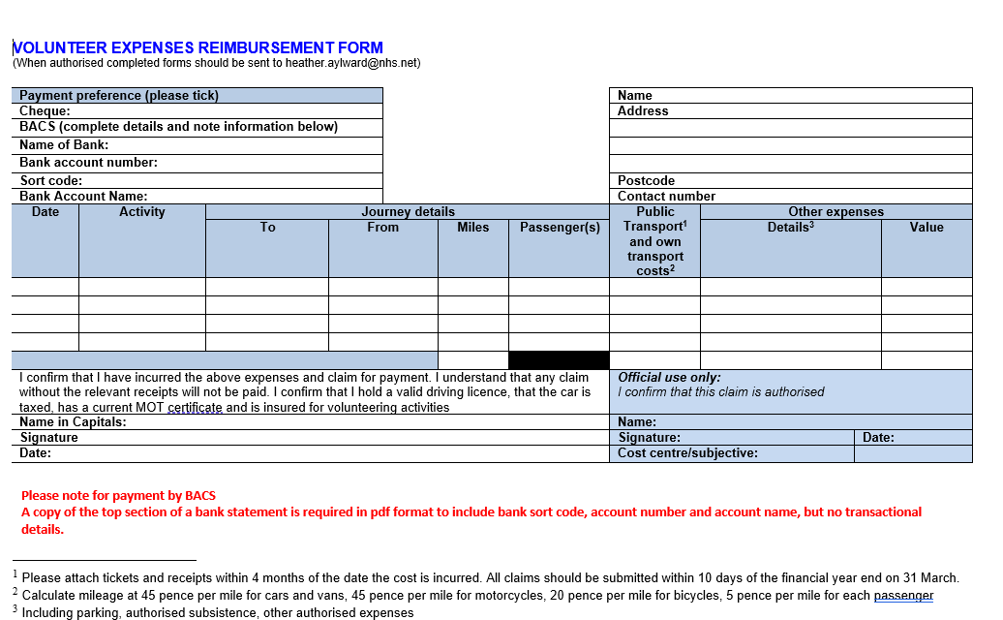

**Appendix 2**

**Equality Impact Assessment and Health Inequality Impact Assessment**

# Equality Analysis

|  |
| --- |
| **Title of policy, service, proposal etc being assessed:** |
| Volunteer Reimbursement Policy |

|  |
| --- |
| **What are the intended outcomes of this work?** To reduce barriers to volunteer participation by eliminating or reducing financial barriers to involvement |
| **How will these outcomes be achieved?**  By implementing the policy to pay out of pocket expenses and reducing financial barriers to involvement |
| **Who will be affected by this work?**  Volunteers and local people |
|  |
| **Evidence** |
| **Impact Assessment Not Required** This policy is to ensure all volunteers have access to out of pocket expenses and that no individual is disadvantaged or excluded because of costs incurred during participation |
| **Impact Assessment Required** **What evidence have you considered?** Against each of the protected characteristics below list the main sources of data, research, and other sources of evidence (including full references) reviewed to determine impact on each equality group.  If you are submitting no evidence against a protected characteristic, please explain why.  If there are gaps in evidence, please state how (and when) you will gather evidence and review the equality impact assessment in the Next Steps section of this document.  Evidence for all groups could include population data and service usage data, |
| **Age** : the policy is to ensure that volunteers can participate at no cost to themselves. A number of participants will be retired and on reduced income, whilst others such as members of the Youth Council (over 16s) will not be receiving income so will need access to transport to participate. These are covered in the policy. |
| **Disability** The policy is to ensure that volunteers can participate at no cost to themselves, for example access to transport and signers. This also covers taxis when required and costs of a personal assistant if needed. |
| **Gender reassignment (including transgender)** Removing financial barriers to participation, no specific measures identified for this protected characteristic |
| **Marriage and civil partnership** Removing financial barriers to participation, no specific measures identified for this protected characteristic |
| **Pregnancy and maternity** This policy will cover child care costs if required, to ensure that those with small children are not prevented from participating because of lack of child care. |
| **Race** This policy covers interpretation and translation support if needed. |
| **Religion or belief** Removing financial barriers to participation, no specific measures identified for this protected characteristic |
| **Sex** Removing financial barriers to participation, no specific measures identified for this protected characteristic |
| **Sexual orientation** Removing financial barriers to participation, no specific measures identified for this protected characteristic |
| **Carers** Alternative care costs are covered in the policy, to enable carers to have some time away from the person they care for to participate. The section on travel reimbursement also acknowledges that caring responsibilities may be in a consideration in deciding mode of transport for getting to a volunteering activity. |
| **Other identified groups** The policy is to ensure that all volunteers have access to out of pocket expenses and that no individual is disadvantaged or excluded because of costs incurred. |
|  |
| **Engagement and involvement** |
| How have you engaged stakeholders with an interest in protected characteristics in gathering evidence or testing the evidence available? N/A – this is an update of an existing policy |
| How have you engaged stakeholders in testing the policy or programme proposals? N/A – this is an update of an existing policy |
| For each engagement activity, please state who was involved, how and when they were engaged, and the key outputs: |

|  |
| --- |
| **Summary of Analysis**  **Considering the evidence and engagement activity you listed above, please summarise the impact of your work.** This policy helps to encourage volunteer participation in the work of the ICB and ensure that no individual is out of pocket because of their involvement. |
|  |
| **Now consider and detail below how the proposals could support the elimination of discrimination, harassment, and victimisation, advance the equality of opportunity, and promote good relations between groups. This is the part of the Public Sector Equality Duty (see page 2).** |
| **Eliminate discrimination, harassment, and victimisation**This policy will help to broaden the ICB’s engagement with a more diverse mix of volunteers by reducing financial barriers to participation. This will ensure more understanding of different perspectives and more participation from protected characteristic communities. |
| **Advance equality of opportunity.** This policy will support equality of volunteering opportunity by ensuring no individual is disadvantaged due to cost or accessibility |
| **Promote good relations between groups ,** this policy will enable different groups to be involved, sharing understanding and building relationships |

|  |
| --- |
| **Next Steps** |
| **Please give an outline of what you are going to do, based on the gaps, challenges, and opportunities you have identified in the summary of analysis section. This is your action plan and should be SMART.**  This policy to be approved by the ICB Executive team |
| **How will you share the findings of the Equality analysis? This can include sharing through corporate governance or sharing with, for example, other directorates, partner organisations or the public. The completed EqIA will be published on the CCG website either as part of the report on the proposals or separately on the equality and diversity pages.** |

# Health Inequalities Analysis

|  |
| --- |
| **Evidence**  **1. What evidence have you considered to determine what health inequalities exist in relation to your work?** There are barriers to people participating, one of these is financial. This policy is to help ensure that people are not disadvantaged and not able to participate because they cannot afford to. |
| **Impact**  **2. What is the potential impact of your work on health inequalities?** This will support wider participation from different communities by reducing financial barriers to being involved. |
| **3. How can you make sure that your work has the best chance of reducing health inequalities?** Ensuring that people, when asked to participate, are informed that they can claim expenses in line with this policy.  Where waiting for payment will cause hardship a faster payment can be requested, this will be a same day Bank transfer. |
| **Monitor and Evaluation**  **4. How will you monitor and evaluate the effect of your work on health inequalities?**   * Increase in number of people getting involved and claiming expenses |
|  |
| **For your records**  **Name of person(s) who carried out these analyses:**  **Heather Aylward, Engagement Manager** |
| **Date analyses were completed:**  14.11.24 |

|  |
| --- |
| **Equality and Diversity Lead Sign off** |
| 22.11.2024 |